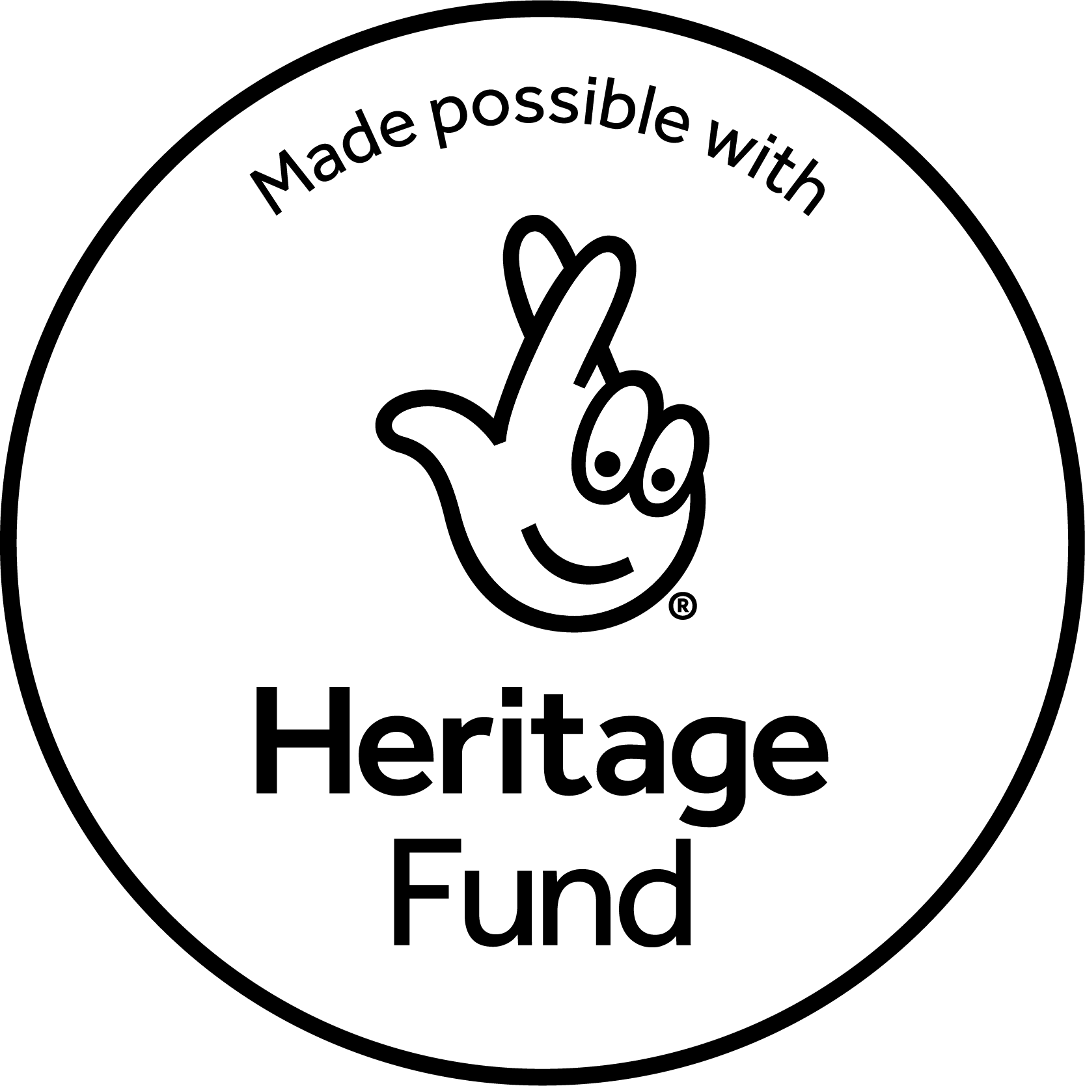

**Engagement Producer**

**Recruitment pack**

**ABOUT FIFTH WORD**

Fifth Word are an award-winning theatre company based in the East Midlands, founded in 2007. We are dedicated to discovering, developing and producing the most exciting playwrights of today, and to working in-depth with under-served communities, empowering people to tell the stories that matter to them through different artistic means.

We produce and tour new plays that are powerful, bold and accessible: amplifying the stories of those who often go unheard and that connect particularly with younger audiences (14-25) and under-represented communities across the UK. We aim to shift perspectives and foster a love of theatre by harnessing its power for storytelling and human connection.

Our flagship engagement projects are created in collaboration with communities that often feel excluded from the arts. We focus on breaking down barriers, developing new talent, and celebrating fresh voices. Everything Fifth Word does is driven by a commitment to fostering creative ambition, championing emerging talent, and amplifying underrepresented voices.

Previous world premiere productions include **Liberation Squares** by Sonali Bhattacharyya  (directed by Milli Bhatia; co-produced with Nottingham Playhouse, in association with Brixton House; national tour Spring 2024), **We Need New Names,** adapted by Mufaro Makubika from the Booker Prize-shortlisted novel by NoViolet Bulawayo (directed by Monique Touko; co-produced with New Perspectives, in association with Brixton House; national tour Spring 2023), **LAVA** by James Fritz (directed by Laura Ford & Angharad Jones; co-produced by Nottingham Playhouse for a full run in Nottingham in 2018 and then a national tour and Soho Theatre run in Spring 2022), **All The Little Lights** by Jane Upton (directed by Laura Ford; in association with Nottingham Playhouse; UK tour/Arcola Theatre 2017 – nominated for Best New Play by the Writers’ Guild Awards and OffWestEnd Awards; Joint Winner of the George Devine Award).

We’re industry leaders in writer development, launching initiatives like the Fifth Word Playwrights group and our previous Most Promising Playwright Award with Nottingham Playhouse. We’ve supported writers like George Devine Award winner Jane Upton and UK Poetry Slam Champion Toby Campion with their first productions.

Our key aims are to:

* Identify and nurture tomorrow’s most exciting playwrights
* Enable greater participation in the arts across the Midlands
* Invest in diversity
* Create productions for younger audiences that have something relevant and urgent to say about living in the world today
* Amplify underrepresented voices
* Produce world-class new writing across the UK

**Our Values**

**EXCELLENCE**

Creating high quality work that has the power to change perceptions and drive positive social change.

**COLLABORATION**

Working in collaboration with external partners to create the best possible opportunities and experiences for communities and audiences.

**CREATIVITY**

Empowering creativity in everyone and platforming under-represented voices in society.

**INNOVATION**

Embracing digital technologies and creating work outside of the traditional theatre space to reach more people.

**INCLUSIVITY**

Widening access to people who are under-represented in the arts and creating inclusive and positive experiences for all, regardless of background or experience level. Celebrating diversity, promoting equality, and challenging discrimination.

**Our Current Programme**

Our 2025/26 plans currently include:

* Showcasing, in June 2025, new work by writers on the [**Fifth Word Playwrights**](https://fifthword.co.uk/productions/fifth-word-playwrights/)group (a 10-month programme of workshops and dedicated support for new and emerging East Midlands playwrights) in partnership with Nottingham Playhouse and Derby Theatre, supported by In Good Company and Writing East Midlands.
* Commissioning and producing the [**Pop Up Plays**](https://fifthword.co.uk/productions/pop-up-plays/)in Autumn 2025: up to 3 new plays that happen in alternative formats and settings outside of a traditional theatre auditorium, in collaboration with Curve and Derby Theatre and with support from Fuel.
* Developing our current commission, a new play by Sophie Ellerby, in collaboration with young people; working towards a world premiere production and tour of the play in 2026.
* Producing a flagship new community engagement programme, **Our Story**,in collaboration with Nottinghamshire Archives, Mansfield Museum, Loughborough University, Notts Trans hub and My Place Youth Centre. **Our Story** will amplify the voices of trans+ individuals in Nottinghamshire, through collecting new oral histories and then reimagining them into dramatised audio stories that will be shared as a podcast series, touring sound installation and pop-up exhibition during 2026.
* Instigating new seed commissions and holding research & development processes with young people for other plays in development.

**Job Description: Engagement Producer**

**Position:**  Engagement producer   
**Reports to:** ArtisticDirector/CEO

**Location:** Hybrid /East Midlands

**Salary:** £31,500- £34,000 pro-rata (depending on experience)

**Hours:** 28 hrs. per week (typically 4 days per week, with flexible hours as needed to fulfil the duties of the role). We’re open to considering 3 or 3.5 days per week to accommodate individual needs. If this would be preferable, please indicate this in your application.

**Contract:** Fixed term for 12 months (with the intention to extend subject to funding)

**Role Overview:**

Fifth Word is seeking a dynamic and motivated Engagement Producer with a strong track record of producing high-quality, creative participation projects across a range of settings. You will bring proven experience in project management, partnership working, and community engagement, along with an understanding of inclusive, co-created practice.

You will work collaboratively with the Artistic Team and Freelancers to deliver meaningful engagement activity that connects with our artistic programme and amplifies underrepresented voices. You will develop and sustain relationships with participants, partners, funders and artists, ensuring that our work is inclusive, impactful, and artistically ambitious.

A core focus of the role will be leading the delivery of ***Our Story***- Fifth Word’s new community engagement project, made possible with funding from The National Lottery Heritage Fund. This flagship programme will work with targeted groups and communities primarily in Nottinghamshire and the East Midlands, uncovering trans+ voices through creative collaboration.

This is a hands-on role that requires excellent administrative, communication, and producing skills, alongside experience working with young people, schools, community groups, and aspiring artists of all ages and backgrounds. You will work flexibly across activities throughout the year, and the role involves travel and in-person delivery across Nottinghamshire, Derby and the wider East Midlands region.

***Our Story***

In partnership with Nottinghamshire Archives, ***Our Story*** is a collaborative heritage project uncovering trans+ lives in Nottinghamshire through oral histories, photography, and film. In collaboration with Mansfield Museum, My Place Youth Centre, Notts Trans Hub, and Loughborough University, the project will train young trans+ creatives and their allies to capture oral histories of local trans+ stories. These interviews will be dramatised and released as a podcast during LGBT+ History Month (February 2026), accompanied by a touring pop-up exhibition of portraits and a sound installation. Launching at Nottinghamshire Archives, the exhibition will tour Mansfield Museum and libraries across the county. All stories will be archived for future generations, aiming to amplify trans+ voices, preserve overlooked histories, and increase representation in museum and archive collections.

*Note: In this project, trans+ is used as an inclusive umbrella term to refer to people whose gender identity or expression differs from the sex they were assigned at birth. This includes, but is not limited to, transgender, non-binary, genderqueer, gender non-conforming, and gender questioning individuals. The “+” acknowledges the broad spectrum of gender-diverse experiences beyond any single label.*

**Main responsibilities.**

**Community Engagement and Producing**

* Lead on the delivery of Fifth Word’s participation projects, including all logistical planning, safeguarding, budgeting, financial record keeping and administration
* Organise and manage all logistical aspects appropriate to producing these activities, including recruiting participants, liaising with venues/partners/artists, and communicating with participants/organisations that support or facilitate their involvement
* Recruit and line-manage freelance project staff for our participation projects
* Initiate and maintain relationships with a wide variety of community and youth groups and schools about projects and engagement opportunities.
* Devise and produce participation or education activities, materials and/or resources (live, print and digital)
* Support the delivery of our artistic development programmes, such as Fifth Word Playwrights, in collaboration with our Creative Associate.
* Attend all Fifth Word young people’s sessions undertaken in person, delegating where appropriate.
* Develop and deliver a programme of wrap-around activity to accompany our touring productions
* Ensure Fifth Word remains fully compliant with all safeguarding legislation and best practice associated with working with young people or any individuals at risk.
* Produce a comprehensive risk assessment for all in-person participation and engagement activities
* **Play a key role in shaping and delivering** the review and development of Fifth Word’s Engagement and Participation Strategy over the next six months, with a focus on expanding work with young people in the East Midlands and deepening co-creation and collaboration with communities.

***Our Story***

* Lead on the recruitment of participants, interviewees and volunteers, including arranging and running community drop-in sessions
* Research and make connections with relevant community groups, regional networks and community members who can relate to these stories; gather advice as needed on how best to support the needs of the participating individuals/groups.
* Develop relationships with key partners from the creative learning and heritage sector.
* Lead on recruiting freelance facilitators and artists for the project, including oral history specialist, film-makers, photographer, sound designer, storytelling consultant, dramaturg, graphic designer; aiming to widen and further diversify the pool of freelance artists that Fifth Word engage with.
* Lead on all practical aspects of arranging the training workshops and the interview sessions, including confirming scheduling, liaising with facilitators, booking space as needed, ensuring technical requirements are fulfilled for filming, audio recording and photography, and any other general logistics.
* Be first point of contact for all participants, volunteers and interviewees, ensuring all necessary information is disseminated to them and they feel adequately supported.
* Produce the podcast series: overseeing the coordinating of the recording and editing process and maximising opportunities for collaboration and skills-sharing between participants and professional artists involved.
* Assist on all practical aspects of creating the final pop-up exhibition and installation from the materials captured on the project.
* Liaise with all Exhibition tour venues to arrange for the exhibition to be transferred to each venue and coordinate the practicalities of transportation.
* Plan and coordinate the launch event, to be attended by project participants, volunteers, interviewees, project partners, and the general public.
* Support Fifth Word’s Marketing Associate with the online promotion of the podcast, launch event and pop-up exhibition/ installation, including feeding into the communication & social media campaign, to reach a wide range of audiences and the communities co-creating this project.
* Ensure Fifth Word remains fully compliant with all safeguarding legislation and best practice associated with working with young people or any individuals at risk.
* Produce detailed risk-assessment of all in-person activity.
* The planning and co-ordination work can largely be undertaken remotely, but the Engagement Producer will need to be present in person to oversee:

- Community drop-in sessions as part of the participant recruitment process

- Participants’ introductory & training workshops (Sept/October) in Mansfield

- Interview sessions (late October) & podcast recording sessions (December) in Nottingham

-The Pop-up Exhibition launch event (Feb 26)

**Finance, Reporting & Evaluation**

* Implement comprehensive evaluation processes, ensuring that accurate statistical information is recorded, qualitative assessments are implemented and that activities are fully documented for the purposes of reporting to funders and other stakeholders
* Contribute to the final project evaluation reports and monitoring information.
* Closely track all related project expenditure and ensure it remains in line with project budgets, and regularly update the Executive Producer regarding project finances.
* Maximise access and inclusion throughout all project activity, and share learnings to inform future projects.
* Identify potential fundraising opportunities and contribute to writing funding applications, as appropriate, in collaboration with the Executive Producer.

**General:**

* Maintain close communication with Fifth Word’s artistic team.
* Act as an advocate for Fifth Word, including fostering an understanding of Fifth Word's wider work and goals and promoting these where relevant
* Undertake any other duties as may be reasonably required from time to time

**Person Specification**

**Essential Skills and Experience:**

* **Proven experience in delivering participatory projects within the arts or a related field**
* Flexible, inventive and informed approach to participatory projects which connect to the community and respond to the ethos of Fifth Word
* Experience in facilitation, collaboration, workshop-leading or directing for youth and community groups with insight into the needs of diverse young participants/community members from a range of backgrounds and contexts
* A proven track record of project management in a community arts or heritage setting
* Understanding of the youth and community arts, education and wider performing arts sectors in the UK
* Passion for progressing diversity, equality and inclusion within the arts
* Accomplished written and verbal skills with excellent attention to detail
* Highly organised, self-motivated and effective in planning own time, able to multi-task and to think and work independently
* Experience in managing freelancers
* Audience-focused (especially young people and people of the global majority)
* Perceptive and rigorous evaluation skills
* Confident communicator, able to remain calm under pressure, inspire trust and create great dialogue with participants and collaborators
* Able to work within all Fifth Word policies and procedures, in particular child protection and disclosure, health and safety, equal opportunities, confidentiality and data protection
* The ability to handle confidential and personal information sensitively, in line with safeguarding procedures, especially when working with young people.

**Desirable Skills and Experience:**

* Experience working in the Midlands, with established networks in the region’s arts/and or community sector
* Knowledge of the local communities and demographics of Nottingham/Nottinghamshire and Derby/Derbyshire
* Knowledge and understanding of the lived experiences of trans+ people
* Experience of working on participatory heritage projects
* Knowledge and experience in co-creating new plays
* Experience of working with schools, academies, colleges and/or universities
* Knowledge of touring theatre and new writing
* Qualification in Community/Youth Arts or an Arts-related subject
* Established connections with schools, institutions, and community groups in Derby, Nottinghamshire, as well as the wider East Midlands, that these projects intend to reach.

**Equality, Diversity and Inclusion**

We are an equal opportunities employer, and we encourage applications from all suitably qualified persons, regardless of race, sex, gender identity, disability, sexual orientation, religion/belief or age. We actively welcome applications from those currently underrepresented in the arts sector.

**Terms of Employment**

|  |  |
| --- | --- |
| **Salary** | **£31,500- £34,000 pro rata** (depending on experience) |
| **Contract** | Fixed term for 12 months (with the intention to extend, subject to funding) |
| **Pension** | Auto-enrolment in the company pension scheme with 3% employer contribution |
| **Hours** | 28 hours per week (excluding breaks), typically 4 days a week with flexible hours as needed to fulfil the duties of the role. Evening and weekend working may be required. If additional hours are worked no overtime will be paid, but time off in lieu (TOIL) can be taken by arrangement with the Artistic Director/CEO.  We are open to a conversation about the number of days worked during this period if the above does not fully align with a preferred applicant’s capacity or existing commitments. For example, we’re open to considering 3 or 3.5 days per week to accommodate individual needs and circumstances- in which case, the salary will be pro-rated accordingly.  **If this would be preferable, please indicate this in your application.** |
| **Holiday** | 28 days paid holiday per annum inclusive of bank holidays (pro-rata for part time working) |
| **Probation** | Six months |
| **Location** | Hybrid/East Midlands.  This is a hybrid role, combining remote work with in-person activities in the East Midlands.  We are an arts company with a lively schedule of events and projects, producing at least one major production annually. This means that there is a managed expectation to travel, work some unsociable hours, and work flexibly in terms of role requirements and hours at certain points in the annual calendar. These periods are planned in advance and will be managed in liaison with the post-holder. |

This role requires the successful candidate to complete a Disclosure and Barring Check (if they do not have a current DBS check).

**How to apply**

**The Deadline for applications is Monday, 7th July 2025, 12 noon**

Please send a covering letter (no more than two pages) outlining what you bring to the role, your reasons for applying, and how your skills and experience fulfil the personal specifications.

In addition, please submit a CV, details of two referees (they will not be contacted prior to interview) and a completed equal opportunity monitoring form, available [**here.**](https://uk.culturecounts.cc/s/5ZN5d1)

Please submit your application to [info@fifthword.co.uk](mailto:info@fifthword.co.uk) with the subject line ‘(Your Name) – Engagement Producer Application’ by the deadline above.

**Questions for us?**

If you would like this information in an alternative format, have any questions about the role, or would like to apply in an alternative way, please contact [info@fifthword.co.uk](mailto:info@fifthword.co.uk)

**Shortlisting and Interviews**

All applicants will be notified by email to confirm whether they have been shortlisted. Interviews for shortlisted candidates will be held the **week commencing 21st July.** The appointed Engagement Producer will be expected to start as soon as possible, though factoring in any necessary notice periods.

Thank you for your interest in the role – we look forward to hearing from you.

Website: [www.fifthword.co.uk](https://fifthword.co.uk/)

Instagram: @[fifthword_theatre](https://www.instagram.com/)

Facebook: @FifthWordTheatre

X: @FifthWord

YouTube: @fifthword

Registered charity. 1211532 Registered company in England and Wales 06581404/ ITC Member